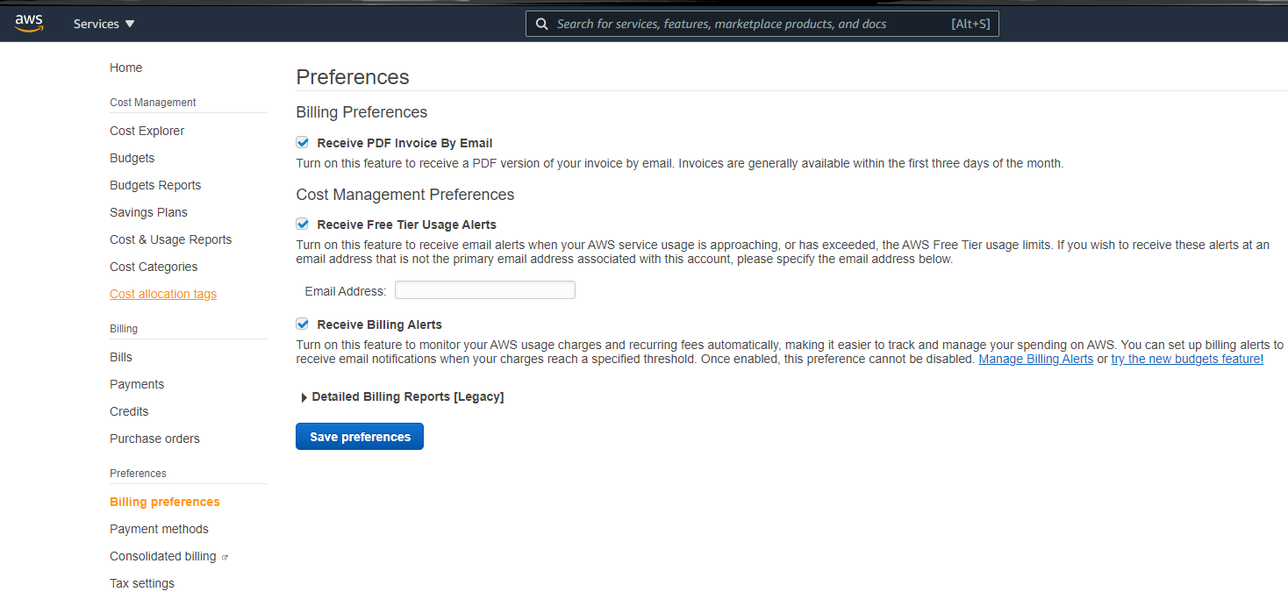**1 - Set up Alarms to not get over billed.**

**Budgets allow you to know whether you go over your defined budget and provides forecast.**

* You get two free budgets per account, after that is 14 dollars per budget.

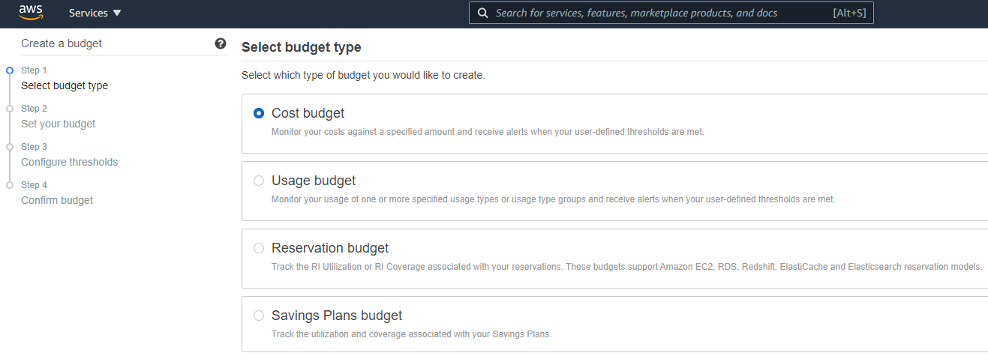

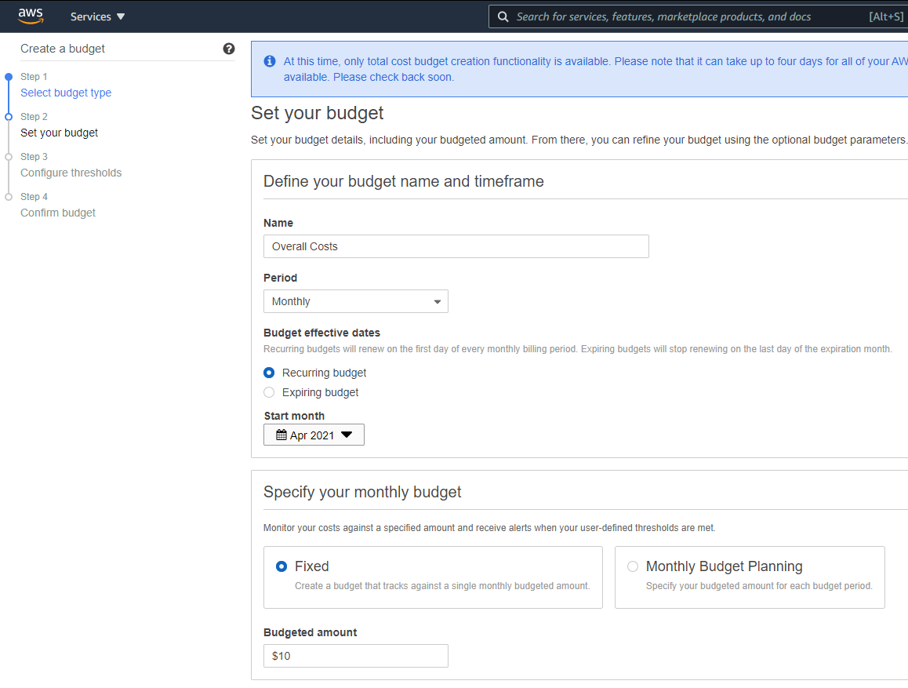

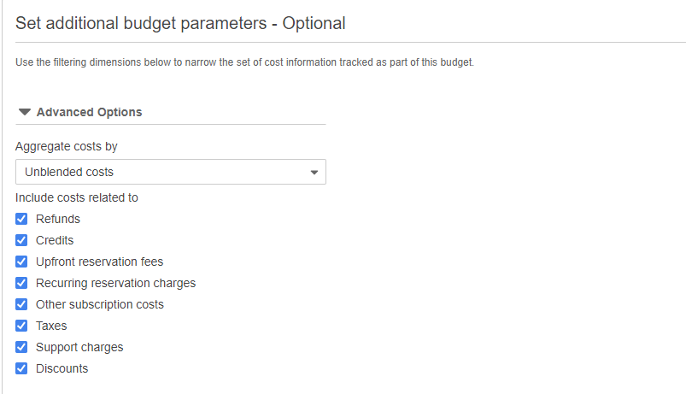

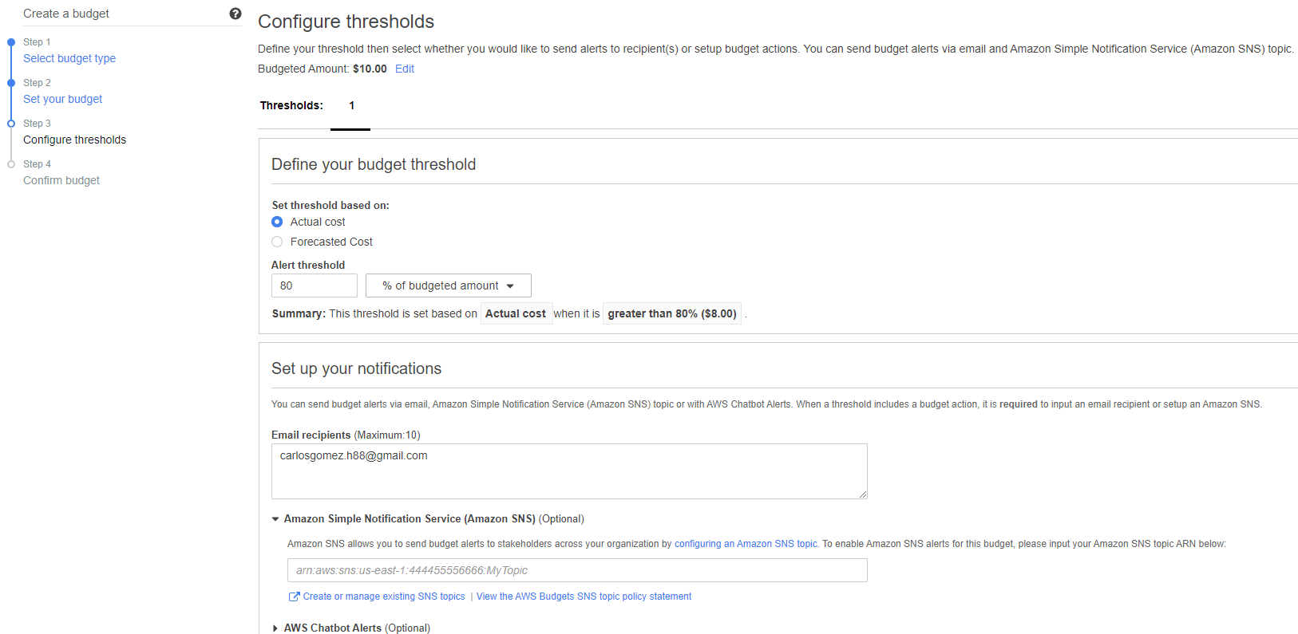

Sd

**After creating the budget, it will look like this:**

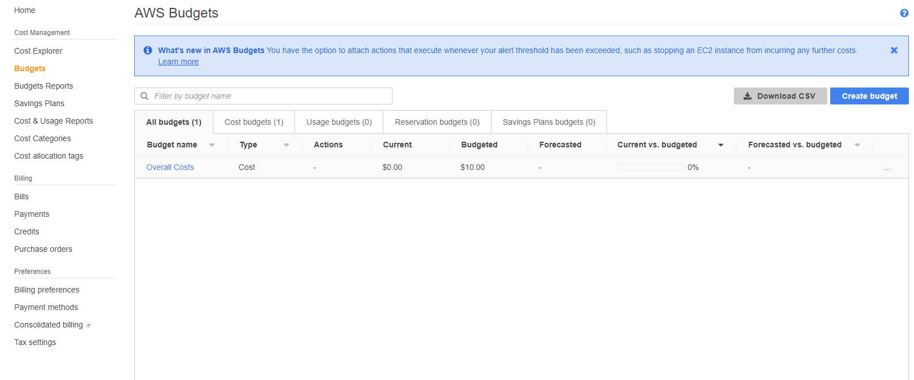

**Billing Alarms:** You get 10 free billing alarms and 1000 free email notifications.

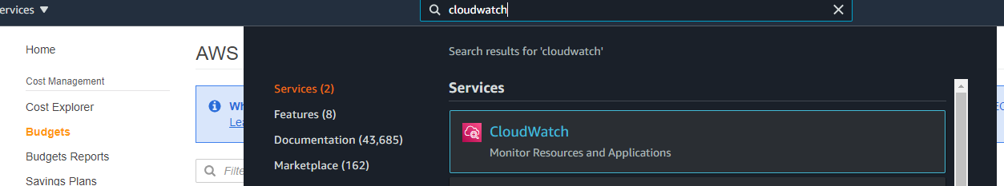Set up the billing Alarm higher than the budget. In this case Budget 10 bucks, billing alarm 50 bucks. You can set up multiple billing alarms at 50 , 100 , 150 to keep track of the leaching.

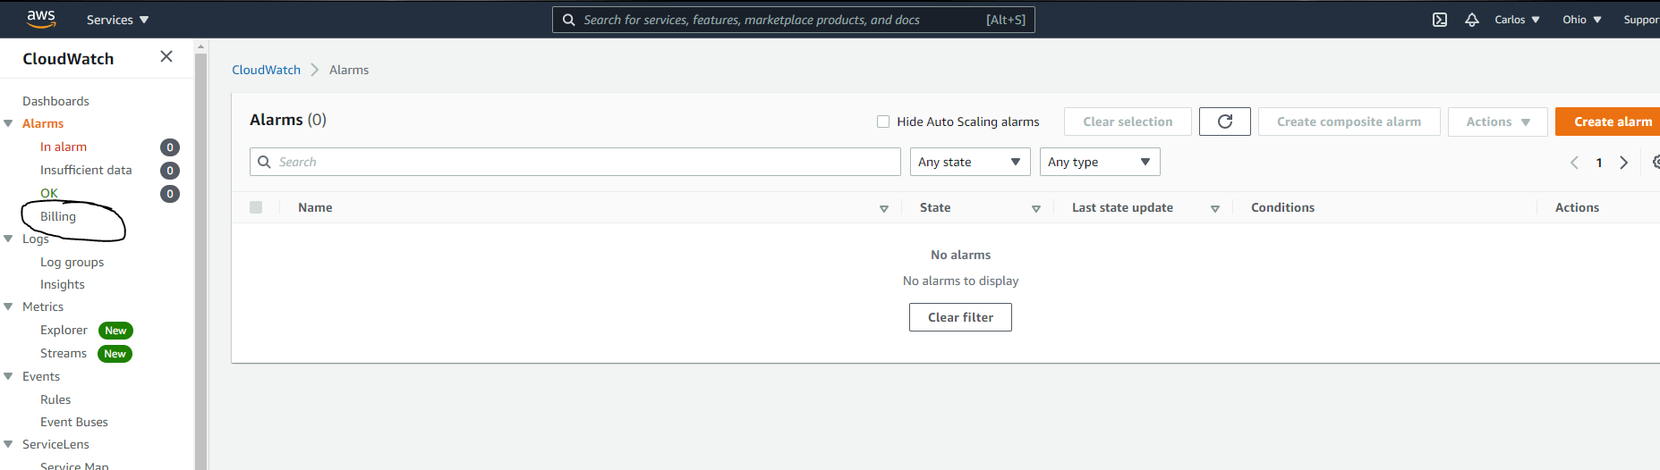

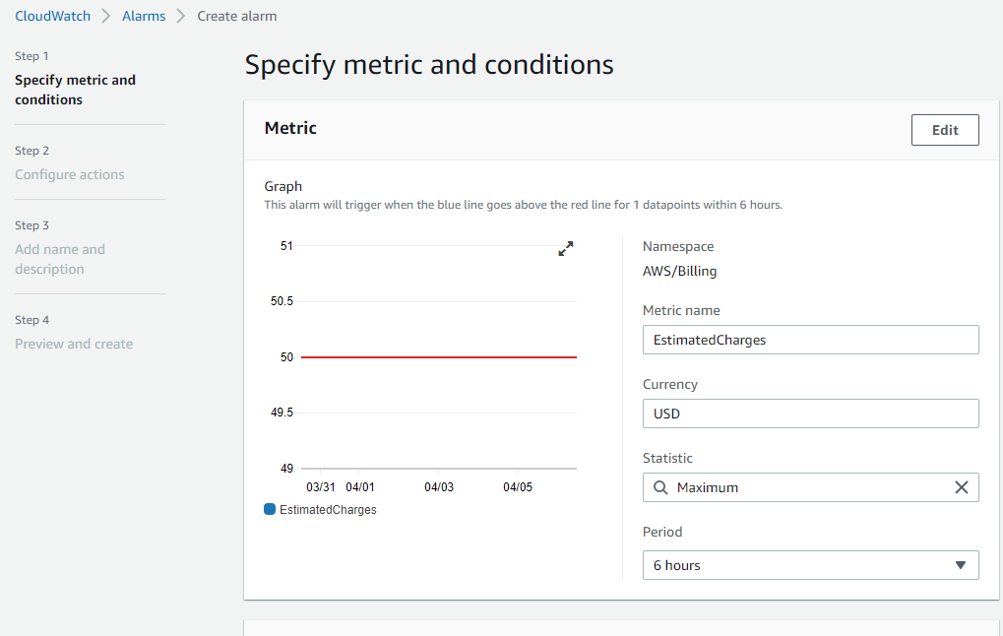

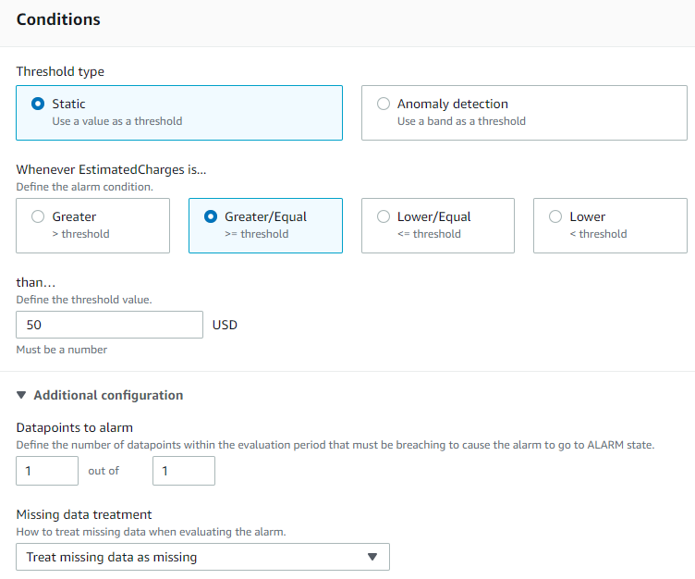

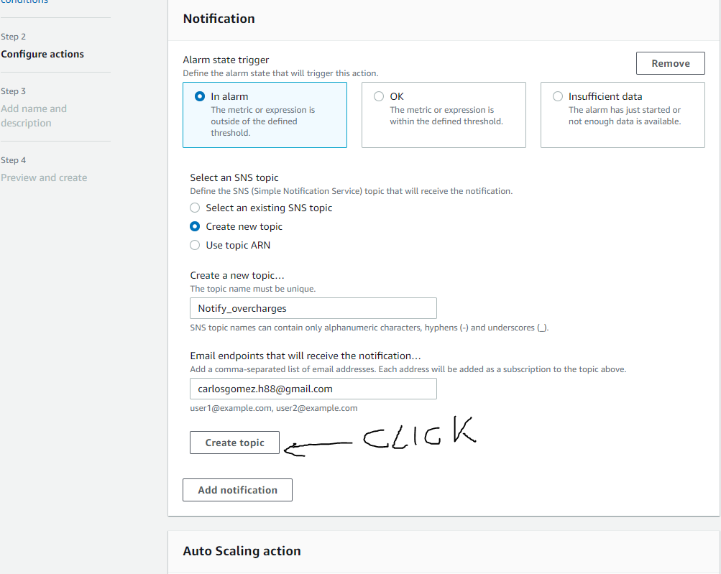

**Once created the alarm will look like this:**

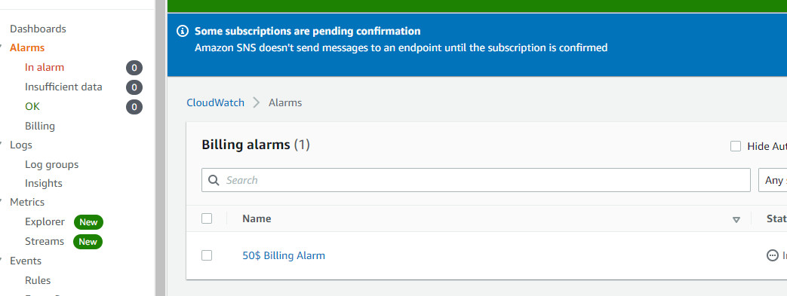

**Do not forget to confirm the email to have the alarm working:**  
 

**Manage your Security Settings and Set up users:**   
  
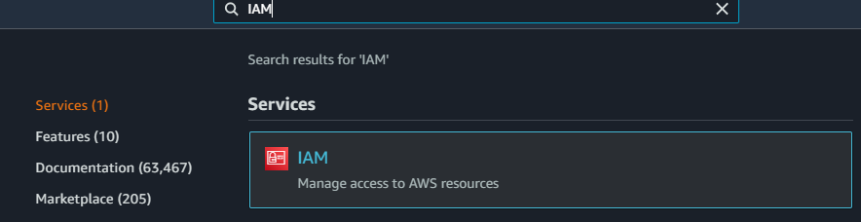

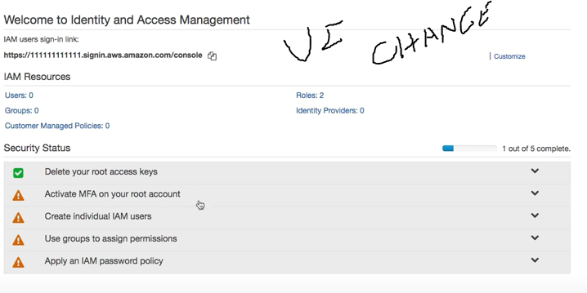

1 – Change the URL of your console to something that makes more sense.  
2 – We should not be using our root account; we should set up groups and users with permissions.

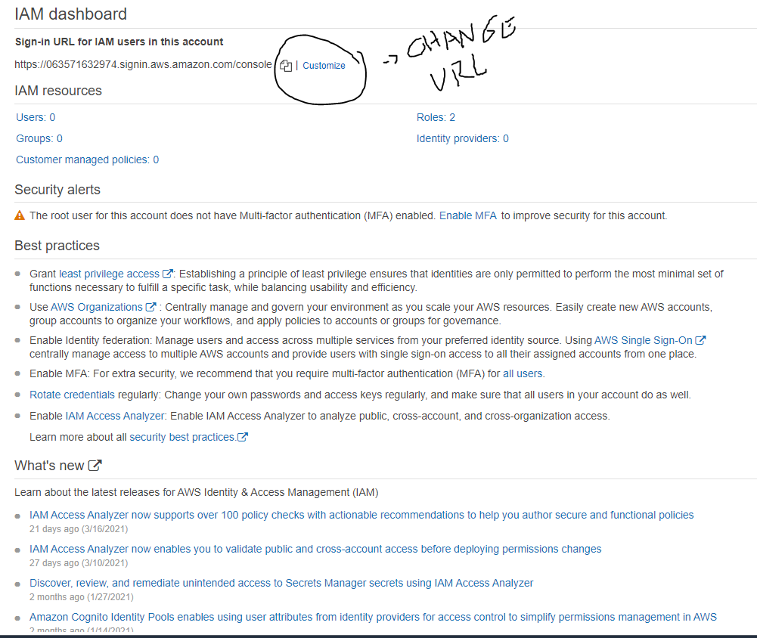

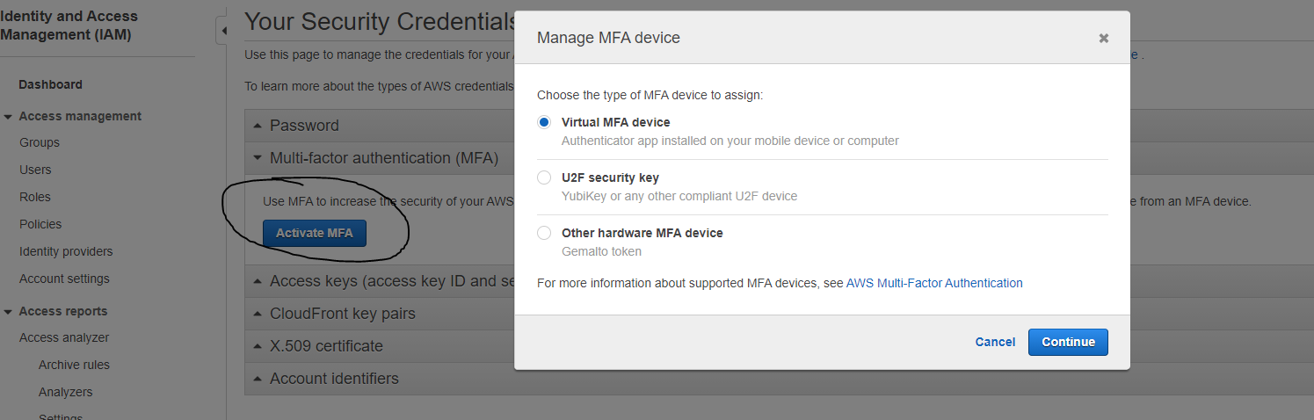**Activate MFA (multifactor-authentication) for root account:**

**Install compatible application in your phone:**  
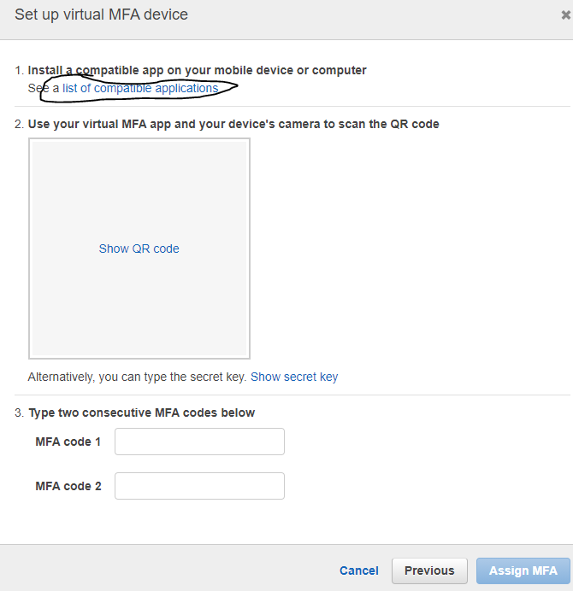

**CREATE USERS:**

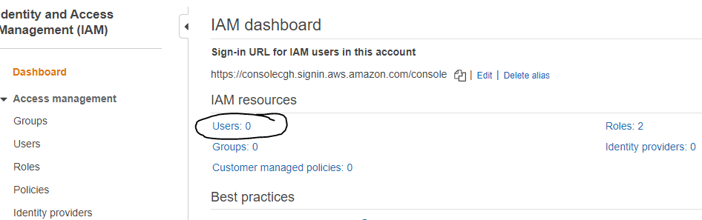

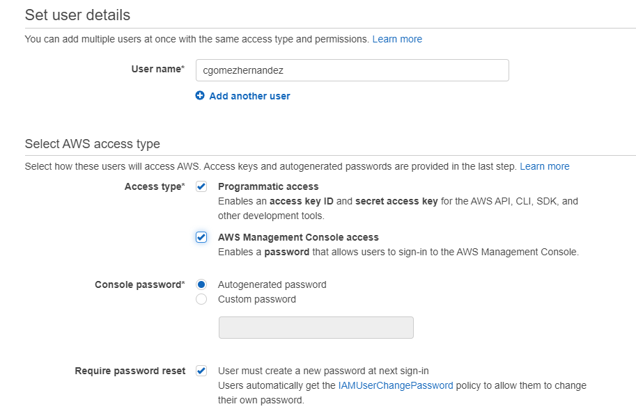

**SET USERS PERMISSIONS: CREATE USER GROUPS**

Power user gives full access with limitations,

Admin user gives the same permissions as root.

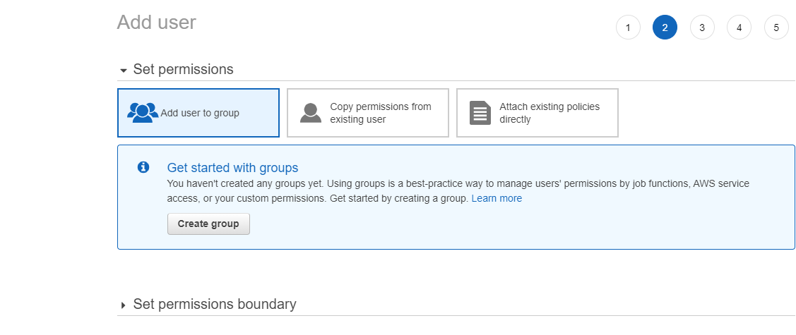

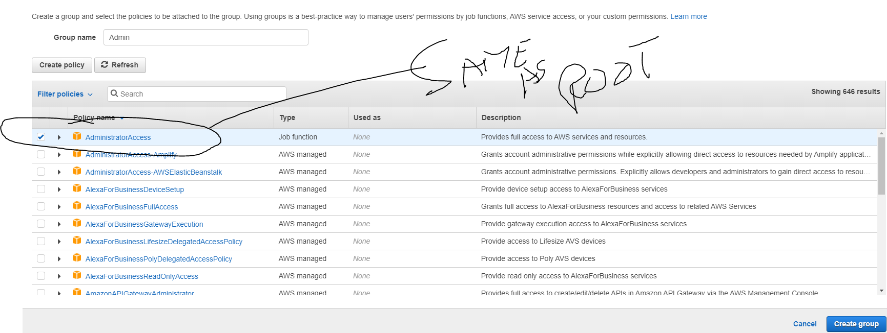

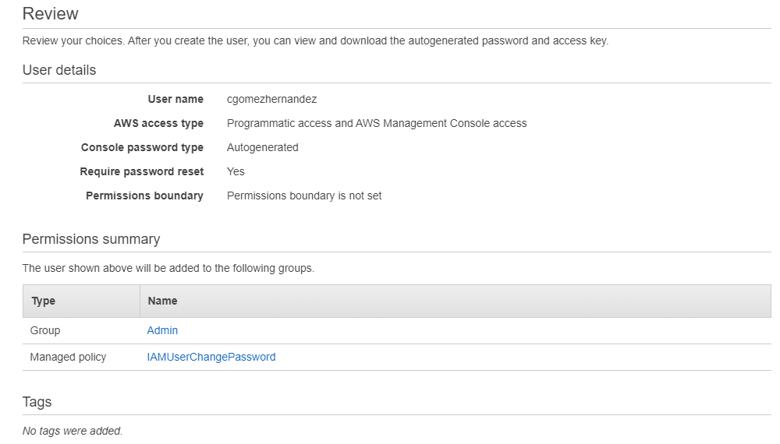

Once the user is created you can send him the url of the console, they will have to log in using the ALIAS ACCOUNT ID located:



Then use the password generated by the console.

**RESTORE ACCESS KEY AND PASSWORD FOR USERS - WHEN NEEDED:**  
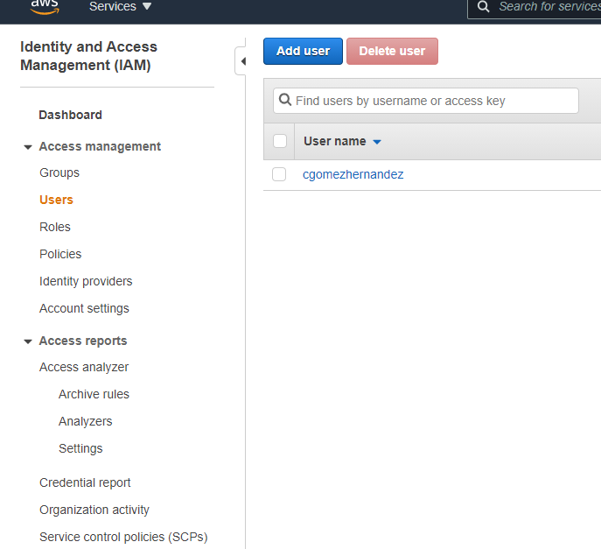

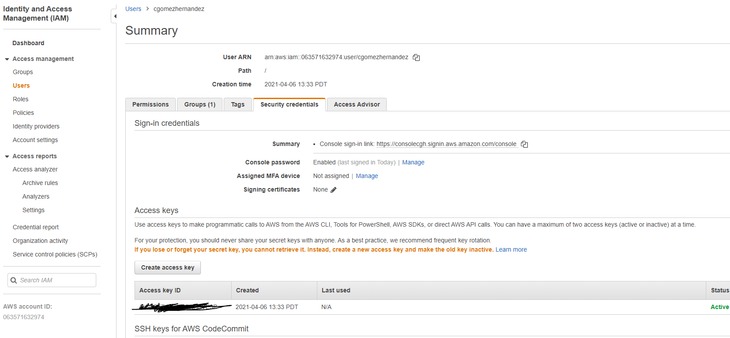

**APPLY IAM password policy as Root:**

These are rules to apply for passwords.

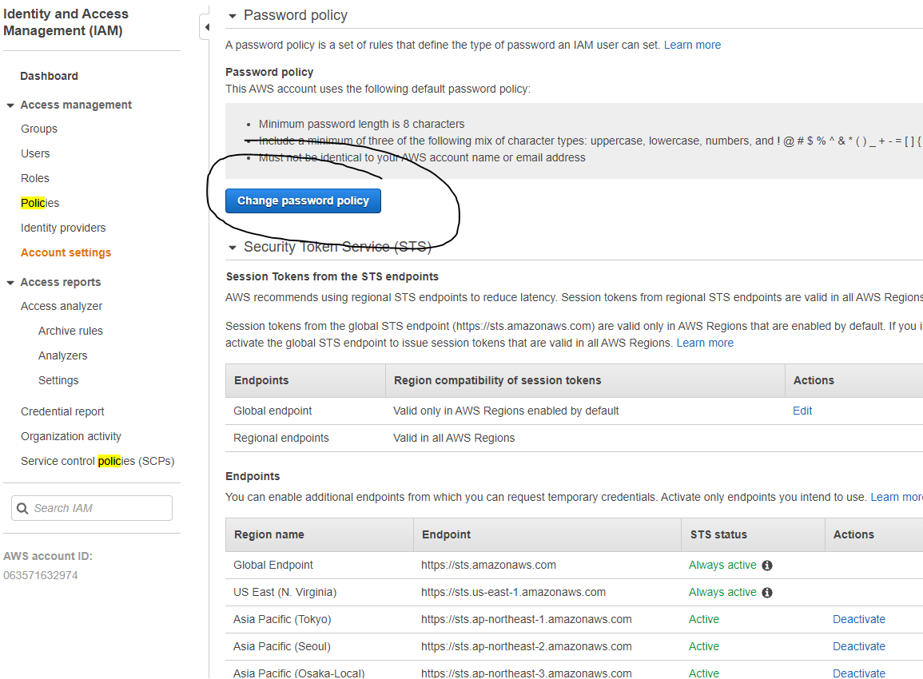

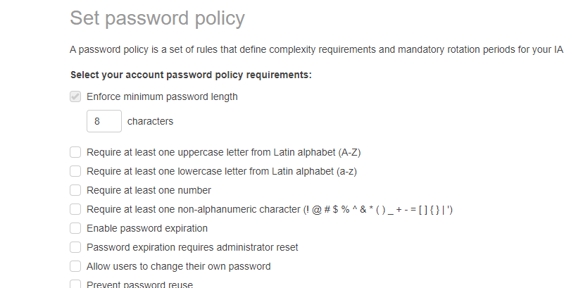

**ELASTIC CLOUD COMPUTE (EC2)**

**How to launch a server - EC2**

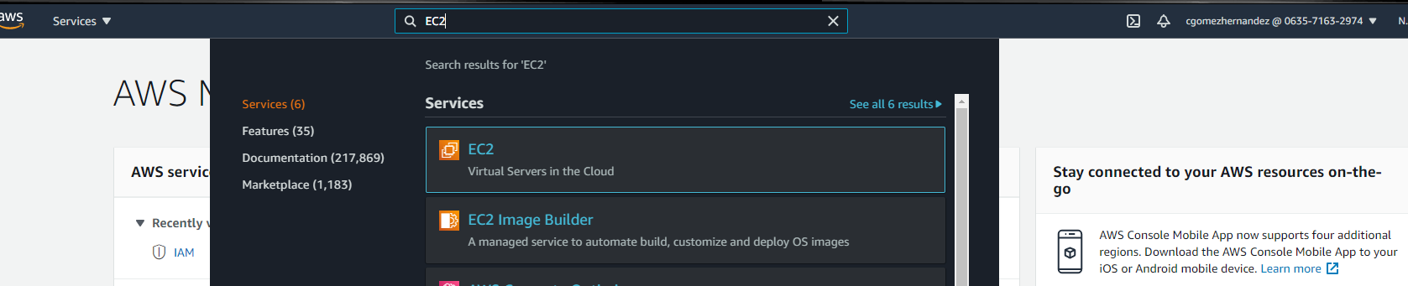

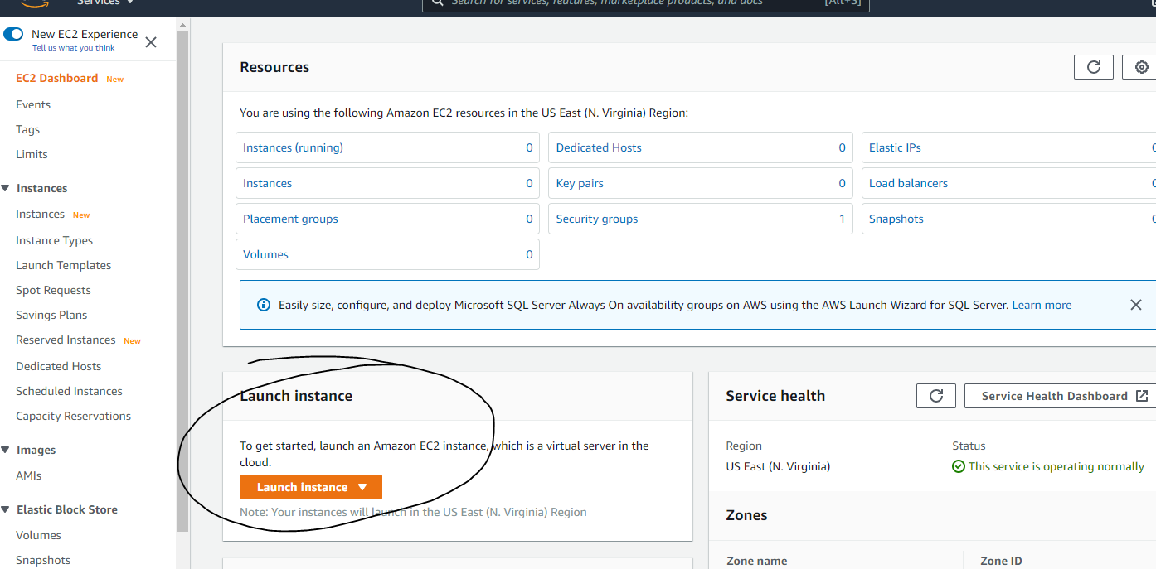

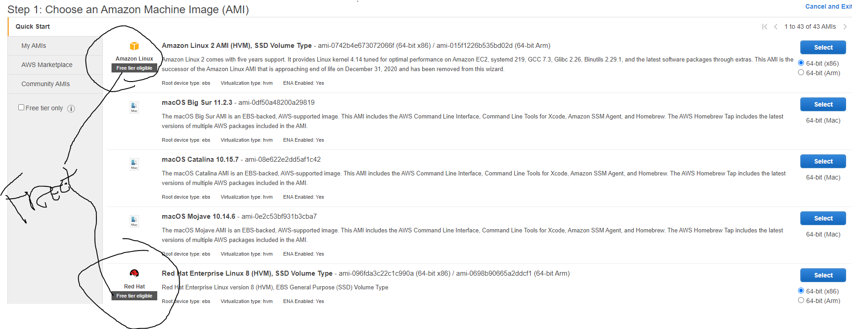

Select

* The OS for servers and the size considered that are considered part of the free tier.
* The memory of your instance (server) and configure its details.
* Create a Identity access Management ( IAM ) role for the server.

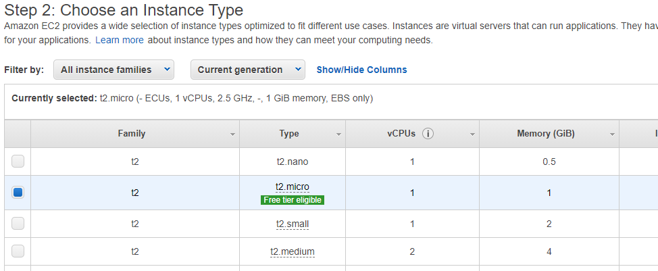

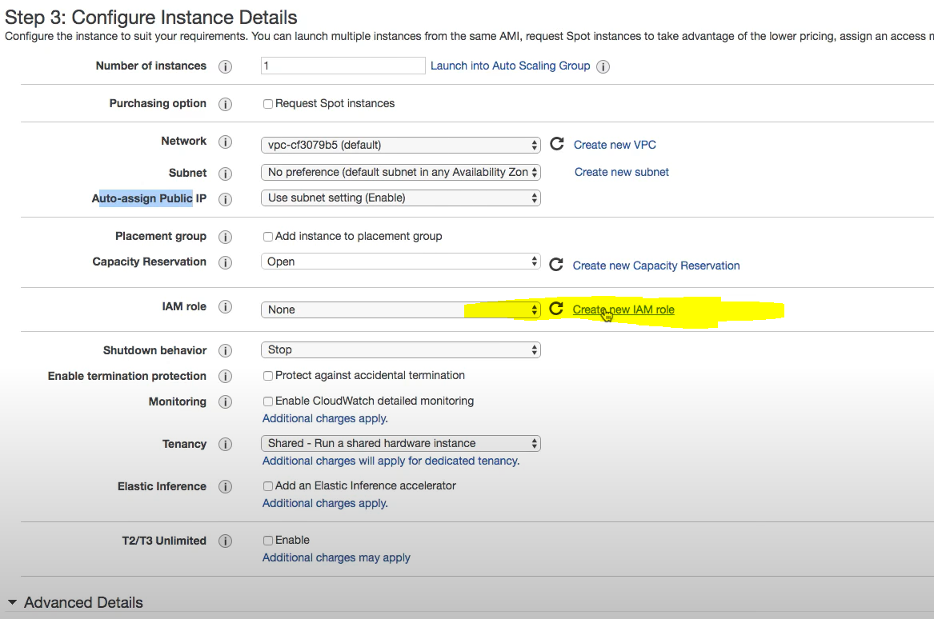

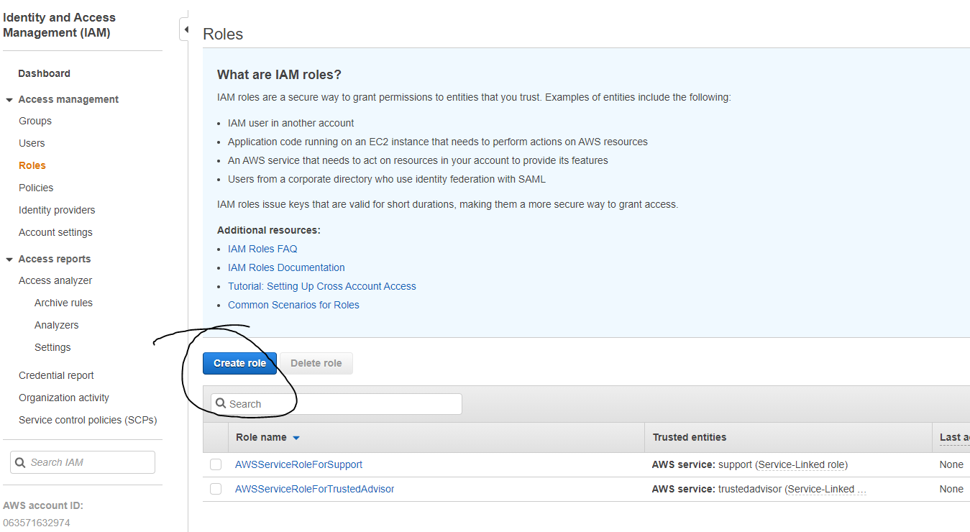**CREATE A NEW ROLE FOR THE EC2 INSTANCE USING - IAM**

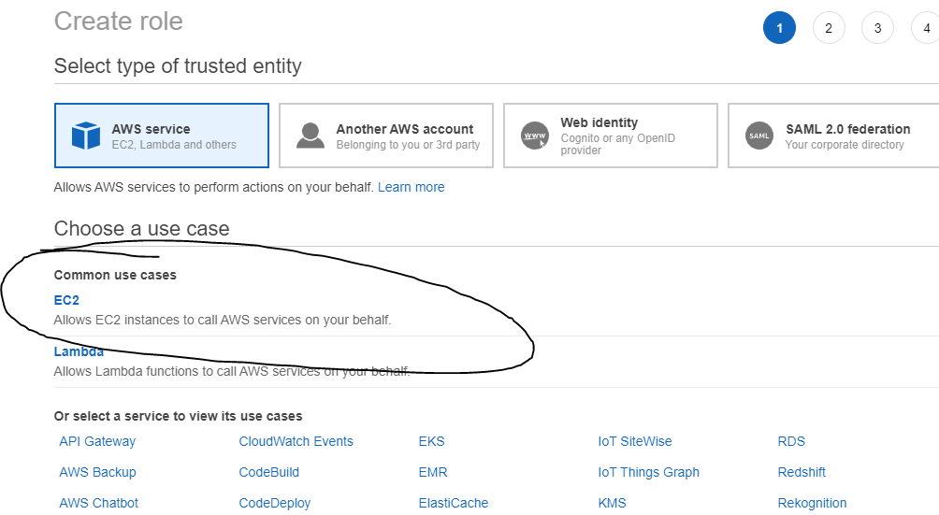

**PROVIDE THE NEW ROLE POLICY:**

There are different ways to log into the server:

The one explained with this policy is Simple Systems Manager ( SSM ) is the one recommended by amazon.

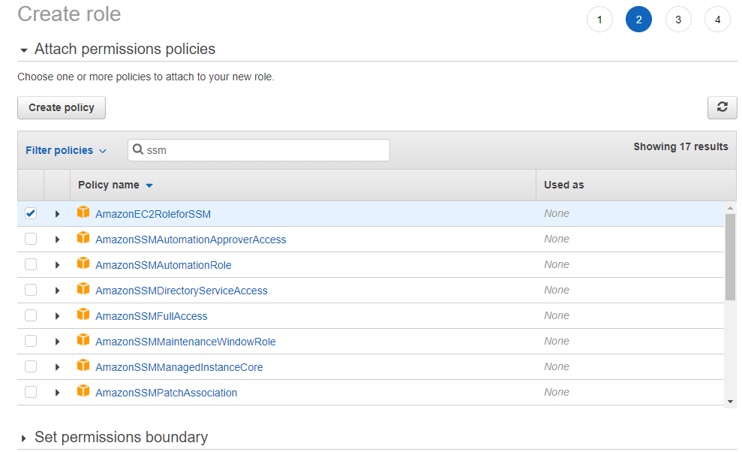

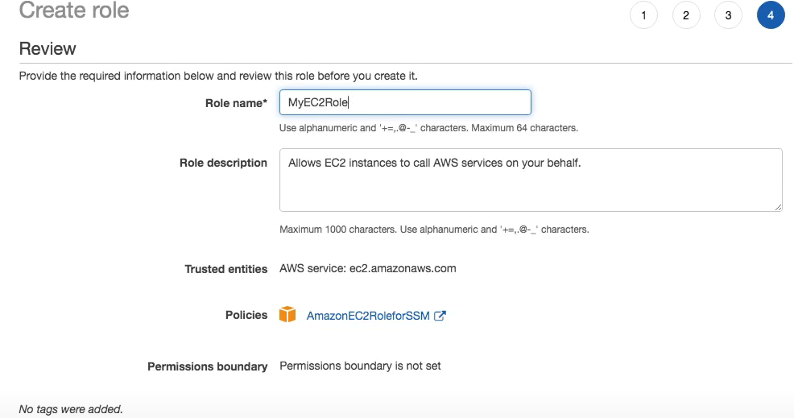

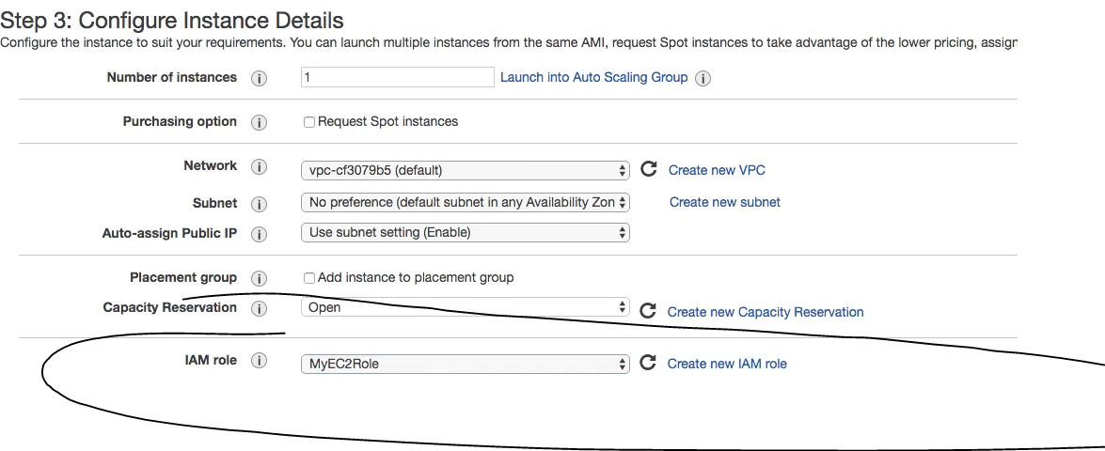

Because we have selected Simple Systems Manager as a way to log into our EC2 instance, we do not need to generate SSH key pair.  
  
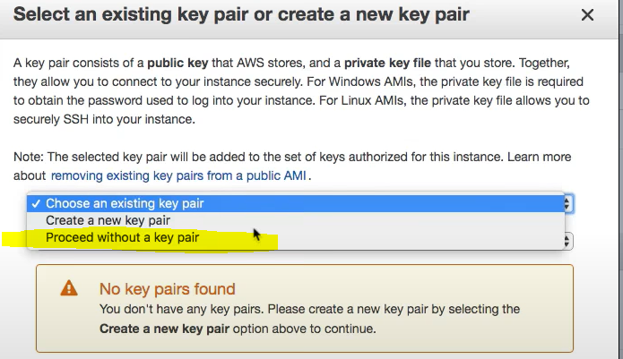

**ACCESS YOUR INSTANCE VIA SSM:**

